**TUTORIAL – 9**

**SANCHIT JAIN**

**21103192**

**B-7**

**1.** #include <iostream>

using namespace std;

int main()

{

    int age;

    cout << "ENter age: ";

    cin >> age;

    try

    {

        if (age < 18)

            throw age;

        cout << "Access Granted: you are old enough" << endl;

        return 0;

    }

    catch (int x)

    {

        cout << "Access Denied: You must be atleast 18 years old" << endl;

        cout << "Age: " << x;

    }

}

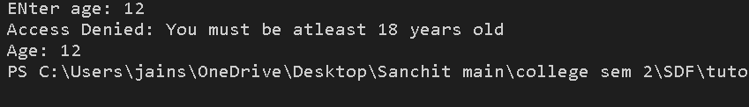

**2.** #include <iostream>

using namespace std;

double zeroDivision(int x,int y)

{

 if(y==0)

 throw "Denominator zero. Division Not possible!";

 double result=(1.0*x)/y;

 return result;

}

int main()

{

 int n1,n2;

 double final;

cout<<"Enter Numerator: ";

cin>>n1;

cout<<"Enter Denominator: ";

cin>>n2;

try

 {

 final=zeroDivision(n1,n2);

 cout<<"Result is: "<<final;

 }

 catch(char const* a)

 {

 cout<<a;

 }

 return 0;

}

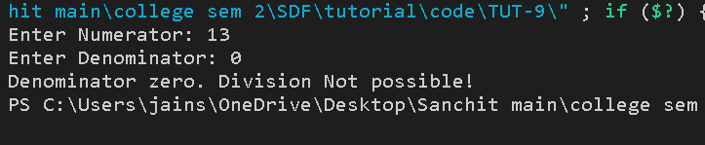

**3.** #include <iostream>

using namespace std;

double harmonic(int x,int y)

{

 if(y==0||x==0)

 throw "Harmonic mean Not possible!";

 if(y==-x)

 throw 101;

 double result=2/((1.0/x)+(1.0/y));

 return result;

}

int main()

{

 int n1,n2;

 double final;

cout<<"Enter Num1: ";

cin>>n1;

cout<<"Enter Num2: ";

cin>>n2;

try

 {

 final=harmonic(n1,n2);

 cout<<"Result is: "<<final;

 }

 catch(char const* a)

 {

 cout<<a;

 }

 catch(int x)

 {

 cout<<"2nd number is the negative of 1st. Harmonic mean not possible!"<<endl;

 }

 return 0;

}

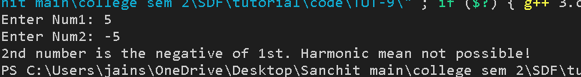

**Q4.**

catch StringOK

catch 1 0

**Q5**. default exception

After Exception

**Q6.** Exception occurred: Thrown value is -1

**Q7**. i) It must be placed immediately after try block T.

(iv) There can be multiple catch handler for a try block T.